**DATABASE MANAGEMENT SYSTEM**

**LAB-6**

**AGGREGATE FUNCTIONS**

**NAME: VISHWAS M**

**SRN : PES2UG20CS390**

**SEC : F**

**DATE : 01/10/2022**

1. Find the average distance between subsequent stations for every train

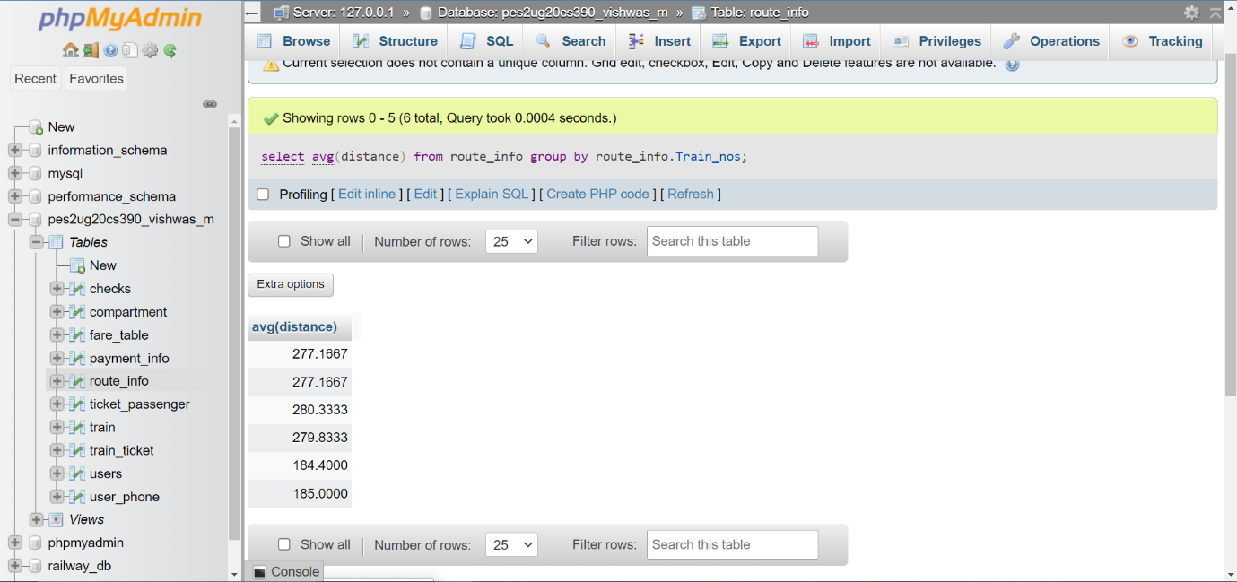

1. Find the average distance between subsequent stations for every train and display them in descending order

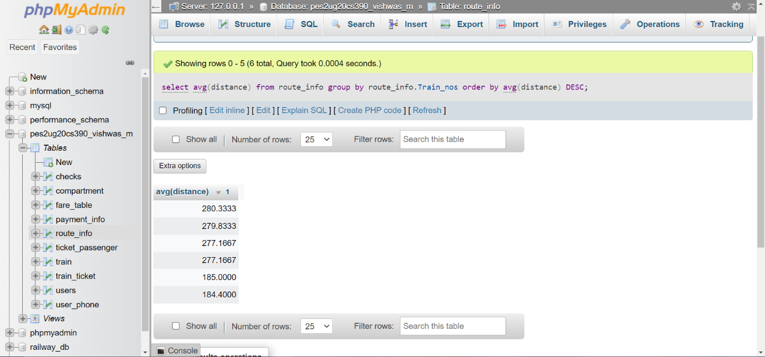

1. Display the list of train numbers and the distance travelled by each in descending order of the distance travelled

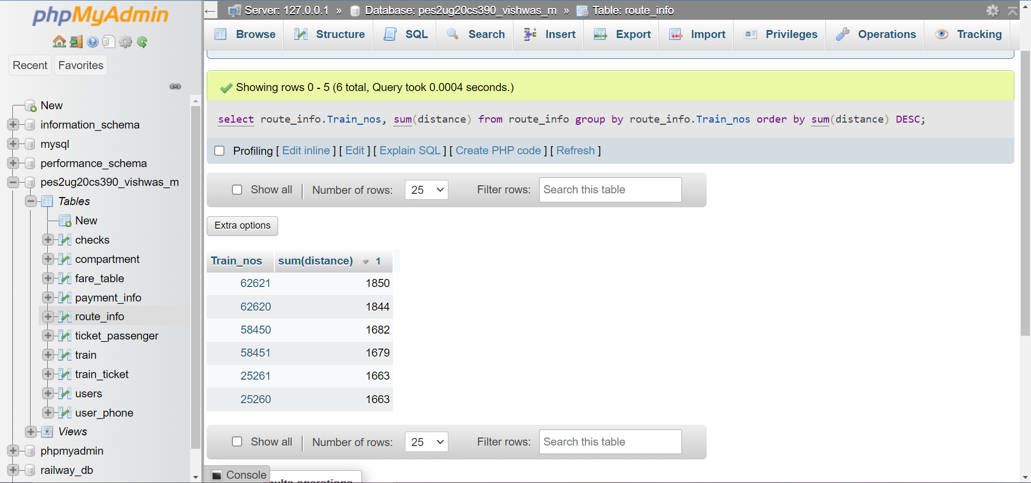

1. List those trains that have maximum and minimum number compartments as train name and number of compartments

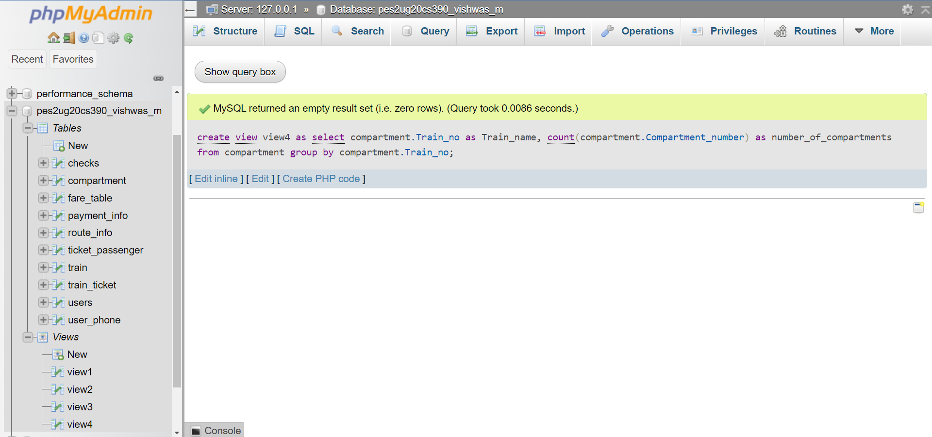

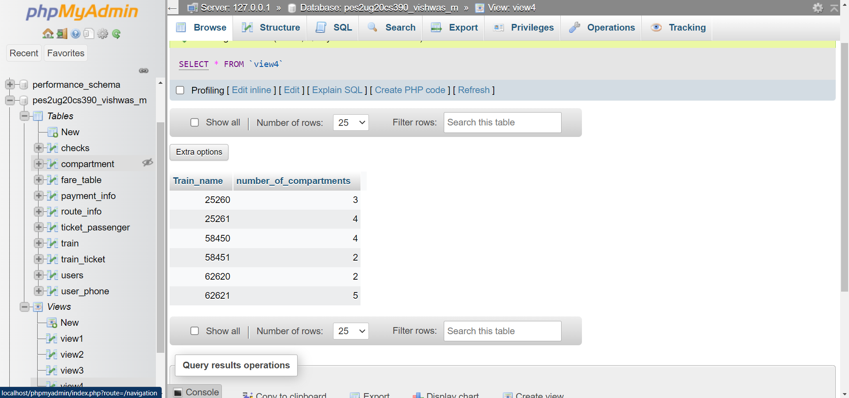

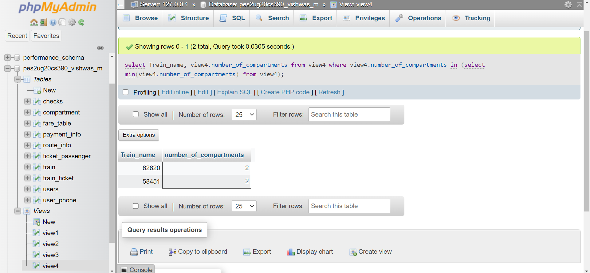

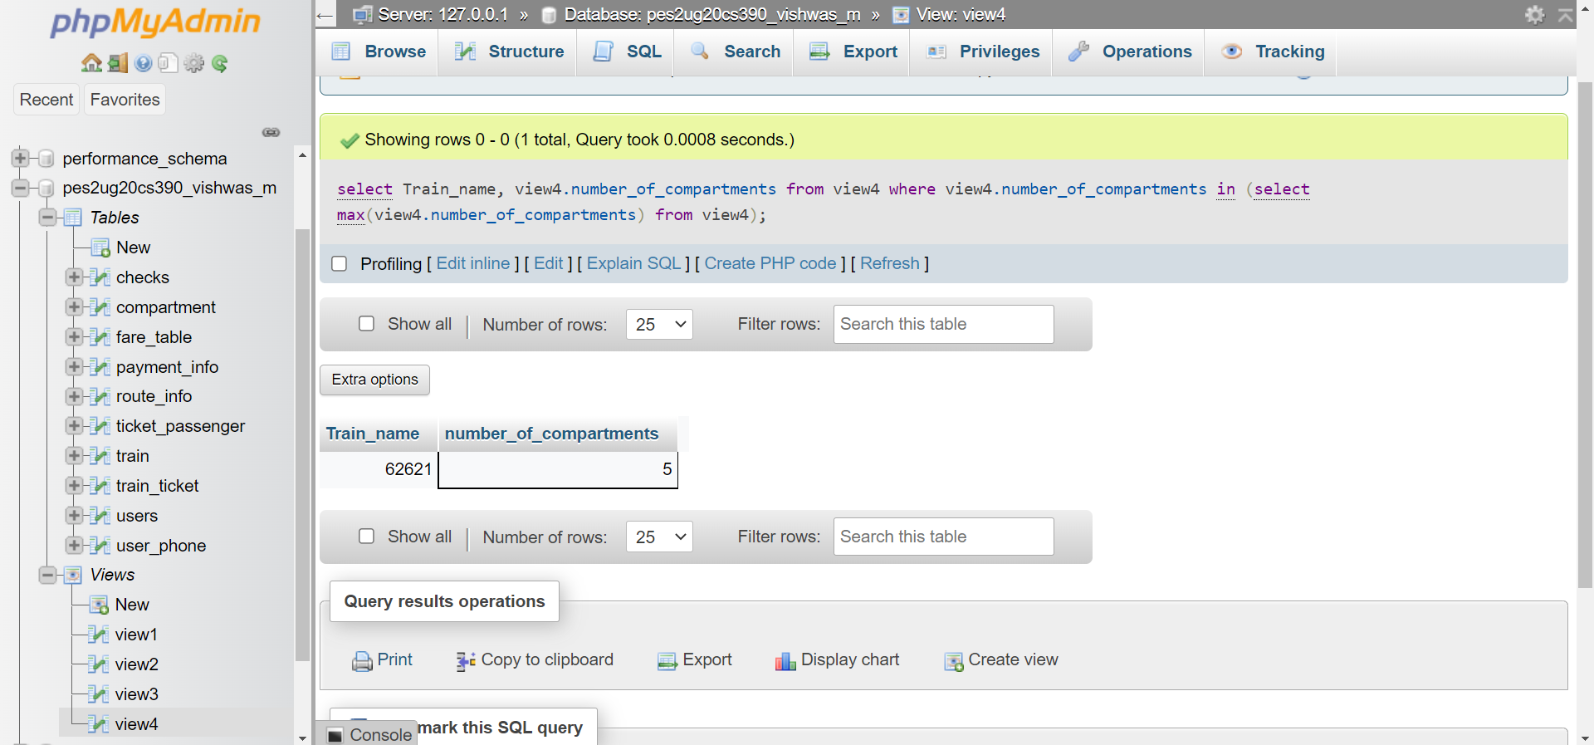

1. Display the number of phone numbers corresponding to the user_id(s) ADM_001, USR_006, USR_10

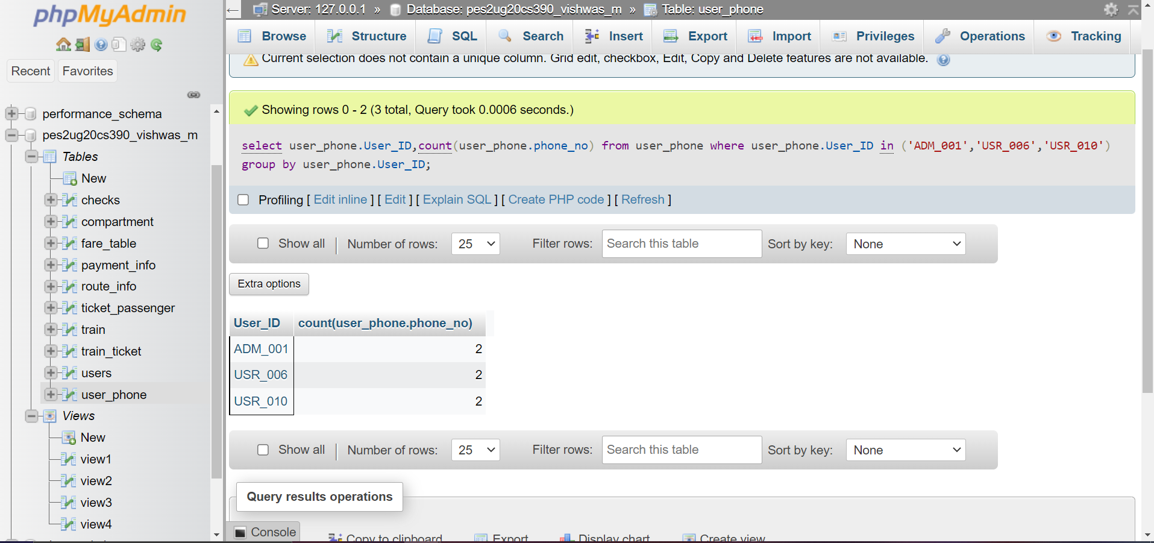

1. Find the average fare per km for each train type specified and display the train type and corresponding average fare per km as ‘Avg_Fare’ in decreasing order of Avg_Fare

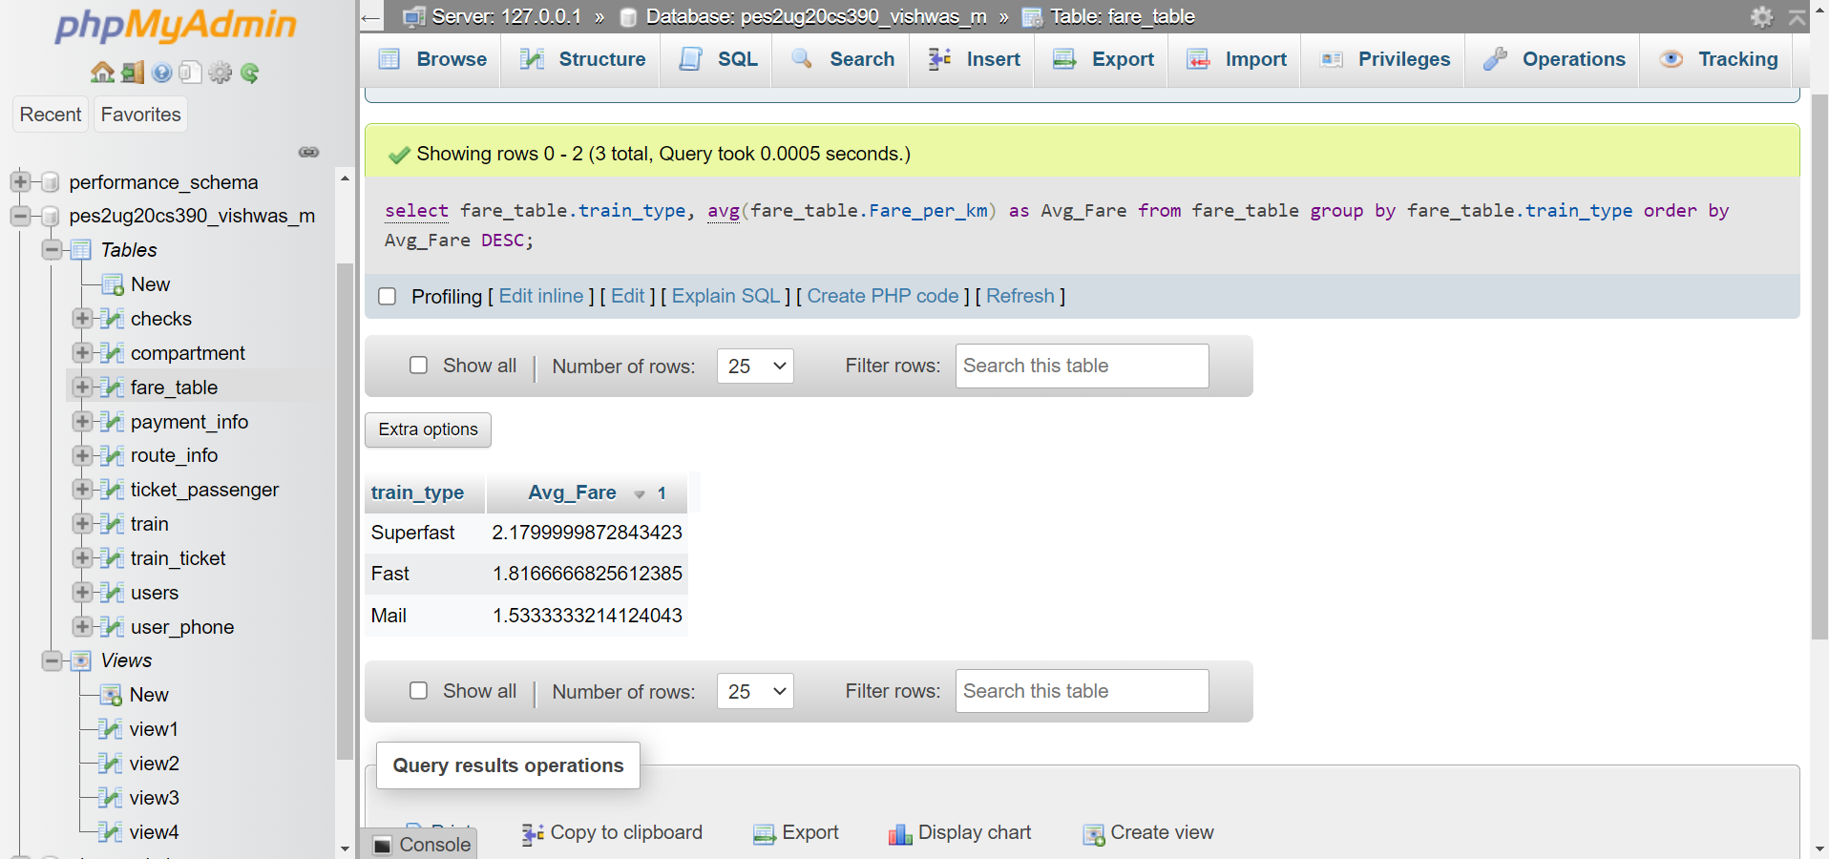

1. Retrieve all details of the oldest passenger.

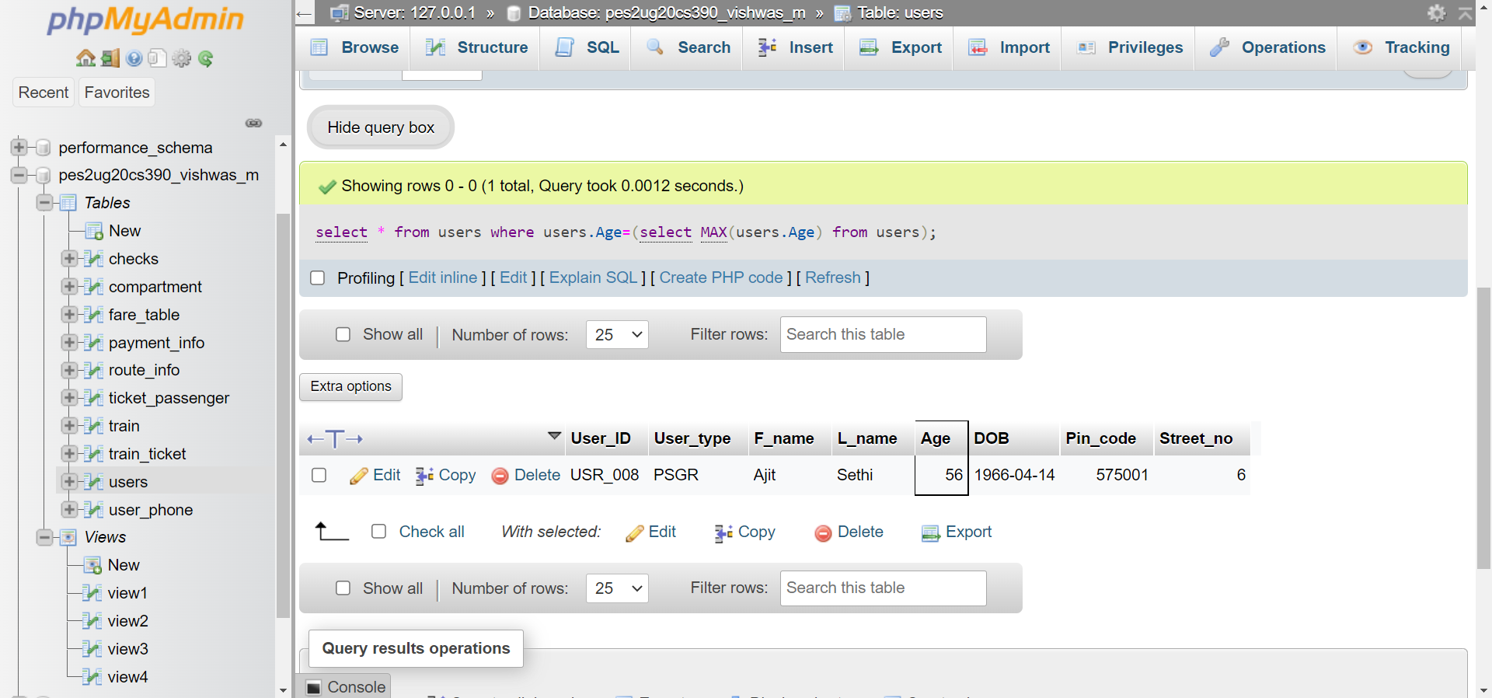

1. Count the number of passengers whose name consists of ‘Ullal’. (Hint: Use the LIKE operator)

